Fitchburg State University

CSC 7132 Operating Systems and Networking

Instructor: Nguyen Thai

Due: 2/17/2017 at 11 PM

Student: Piyusha Jahagirdar

**CSC 7132 Assignment 1: File Systems**

The purpose of this lab is to learn about computer file systems. In this lab, you are to write programs to access a file system. Your programs are to be written in the C language and run on the Linux operating system. Before you start working on your lab, you need to setup your development environment. We will use Ubuntu as our Linux operating system. Therefore, in addition to learning how computer file systems work, you will also learn about virtualization, Linux operating system, and shared files concepts between Windows and Linux.

As you work through the lab be sure to answer all questions (type your answers into this document) and take all screenshots as requested (copy them into the document). For the screenshots, you can use the Snipping Tool that is built-in to Windows to capture the important parts of the lab as highlighted in the document below. Do not delete the contents of this file. When finished, you will submit the document, source code and associated data files to the instructor via Blackboard. DO NOT SUBMIT ZIP FILES OR INDIVIDUAL IMAGES. If you have any questions or need any clarification, see the instructor *before* the deadline.

**ENABLE VIRTUALIZATION**

1. Verify whether virtualization is enabled on your machine.
   1. Go to Task Manager.
   2. Click on Performance tab.
   3. Click on CPU.
2. Enable Virtualization in BIOS, if it is not already enabled.
3. **TAKE A SCREENSHOT** of the CPU screen in Task Manager showing virtualization is enabled and paste it here.

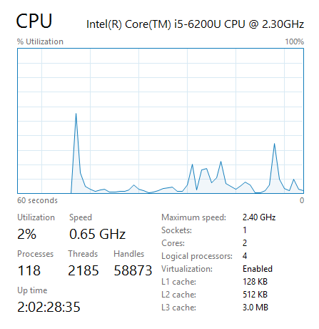

**INSTALL VIRTUALBOX**

1. Navigate to <https://www.virtualbox.org> and download a VirtualBox image based on your machine environment.
2. Follow the installation instructions from VirtualBox.
3. **TAKE A SCREENSHOT** of the VirtualBox welcome screen and paste it here.

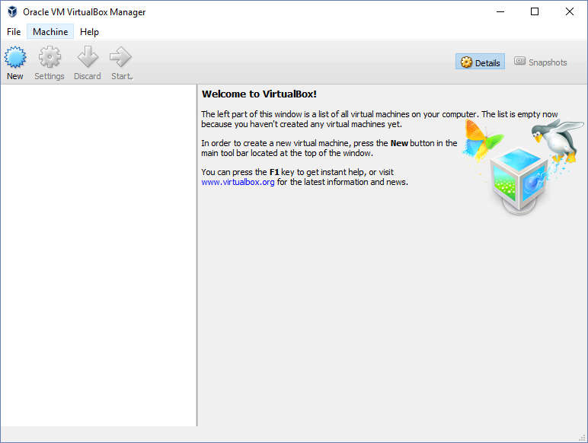

**INSTALL UBUNTU ON VIRTUALBOX**

1. Navigate to <http://www.ubuntu.com> and download an image of the Ubuntu Desktop version.
2. Select the 64-bit or 32-bit based on your laptop hardware.
3. Ubuntu will ask you to donate money. You don’t have to give them money. Just set all the money values to zeroes or click [Not now, take me to the download](https://www.ubuntu.com/download/desktop/thank-you?version=16.04.1&architecture=amd64).
4. Fire up your VirtualBox, if it is not running.
5. Click the New button on the top left corner to open the Create Virtual Machine window
6. Enter *Ubuntu* in the Name field.
7. The Type field should be set to *Linux*.
8. Version should be set to the Ubuntu version that you downloaded.
9. Click Next.
10. You can adjust the memory size. Use the default setting.
11. Click Next.
12. In the Hard disk window, select Create a virtual hard disk now.
13. Click Create.
14. Select VDI (VirtualBox Disk Image).
15. Click Next.
16. Select Dynamically allocated in Storage on physical hard disk window.
17. Click Next.
18. Leave the file location setting as Ubuntu and click Create.
19. You have created a virtual hard disk on VirtualBox. Now install Ubuntu on the virtual disk you just created.
20. Double click on the Ubuntu VirtualBox instance on the left.
21. In Select start-up disk, click on the yellow folders and navigate to the location that you saved the Ubuntu image. Select the Ubuntu image.
22. Click Start.
23. In the Ubuntu Welcome window, click Install Ubuntu.
24. Follow the instructions from Ubuntu installation, but DO NOT select the *Download updates while installing Ubuntu* or *Install this third-party software*…. This will take extra installation time.
25. TAKE A SCREENSHOT showing the Ubuntu is successfully installed and paste it here.

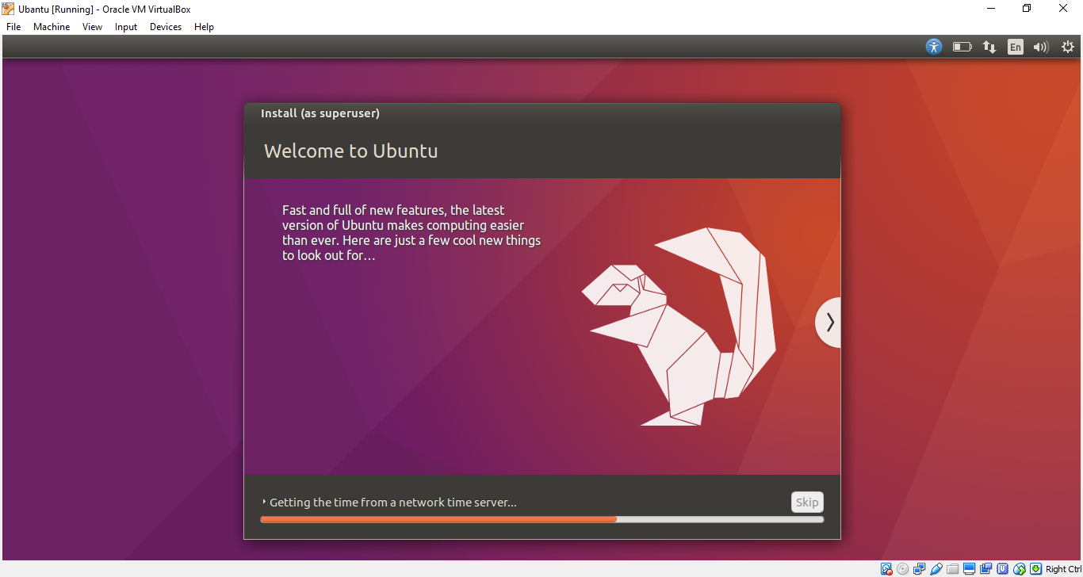

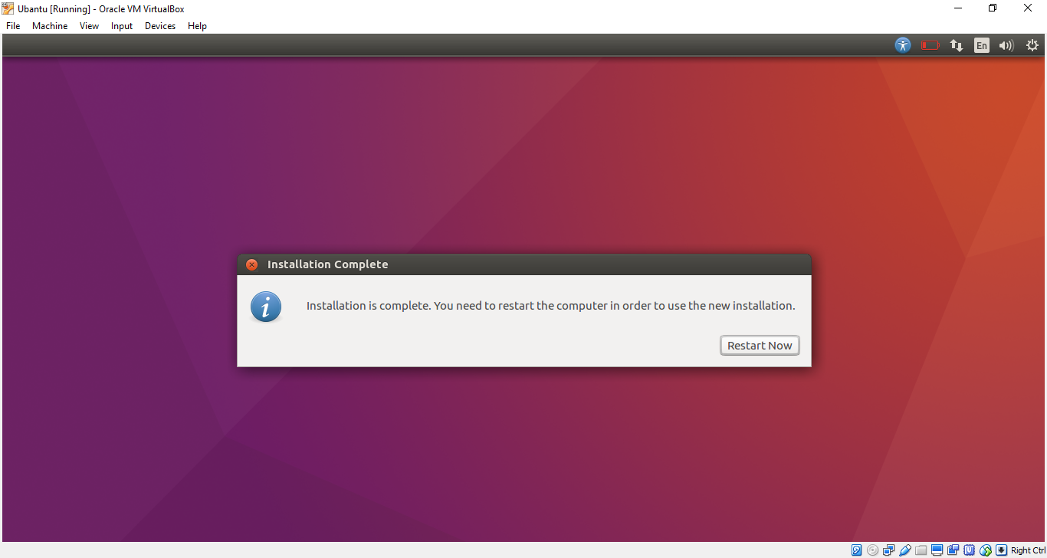

**VERIFY UBUNTU IS WORKING PROPERLY**

1. Ubuntu comes with Firefox web browser already installed.
2. Navigate to [www.weather.com](http://www.weather.com).
3. TAKE A SCREENSHOT of the weather channel showing Ubuntu has connection to the Internet and paste it here.

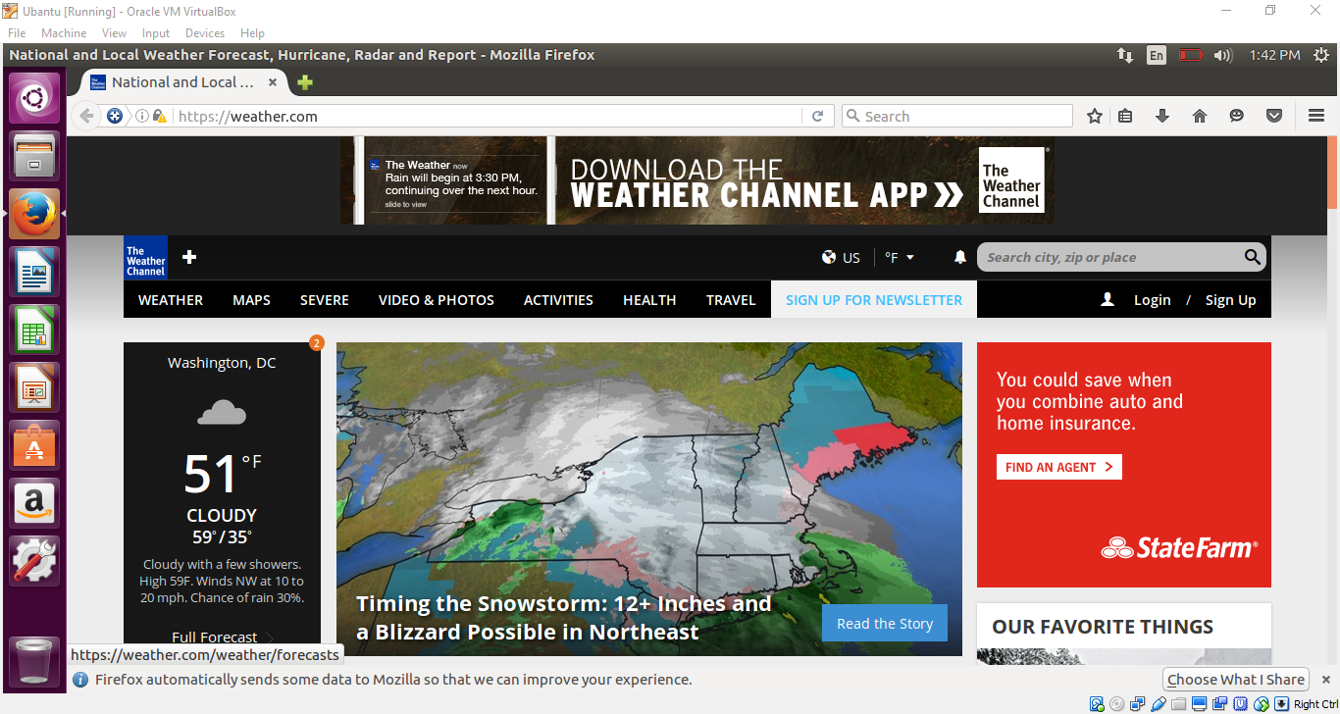

**CREATE WINDOWS-UBUNTU SHARED FOLER**

The purpose of a shared folder is to allow you to transfer files between Windows and Ubuntu environments. You will be developing software on Ubuntu. Once you have completed your software development, after coding and testing, you need to move your works from Ubuntu to Windows. Notice that you need to submit your work to Blackboard that is in Windows.

1. **In Windows:**
2. Create a folder called *SharedFolder_Csc7132* using File Explorer. You can create the folder anywhere in the hard disk. However, I suggest you create the folder at the highest level of your Local Disk to make it easy for navigating to it.
3. Right hand click on the SharedFolder_Csc7132 and select *Properties*.
4. Select Sharing tab.
5. Click Share… button.
6. In the pulldown list, select Everyone.
7. Click Add.
8. Change the permission on Everyone to Read/Write.
9. Click Share button.
10. TAKE A SCREENSHOT of the File Sharing window showing your SharedFolder_Csc7132 folder is shared.

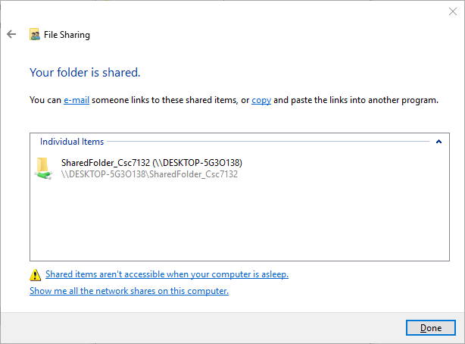

1. Click Done and close the Properties window.
2. **In VirtualBox:**
3. Power down Ubuntu if it is running.
4. Make sure Ubuntu is powered down. Highlight the Ubuntu object in VirtualBox.
5. Click Settingsbutton to open the Settings window and select theGeneral tab.
6. Click Advanced tab.
7. On Snapshot Folder pulldown, select Other…
8. In the popup window, locate the SharedFolder_Csc7132 folder and highlight it.
9. Click Select Folder.
10. Change folder sharing setting on Shared Clipboard and Drag’n’Drop to Bidirectional using the pulldowns.
11. TAKE A SCREENSHOT showing the folder sharing settings in VirtualBox and paste it here.

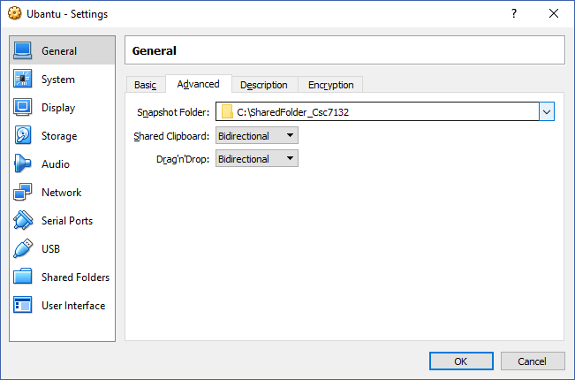

1. Click OK to close the Settings window.
2. **In Ubuntu:**
3. Startup Ubuntu and log in using your username and password.
4. On Devices tab, select Share Folders -> Shared Folder Settings…
5. Click the folder with the “+” symbol on the right-hand side.
6. In the Folder Path pulldown, select Other and locate the SharedFolder_Csc7132 folder.
7. Highlight it and click Select Folder.
8. Check both Auto-mount and Make Permanent selections.
9. Click OK.
10. TAKE A SCREENSHOT of the Shared Folders window showing SharedFolder_Csc7132 is auto-mount and has full access.

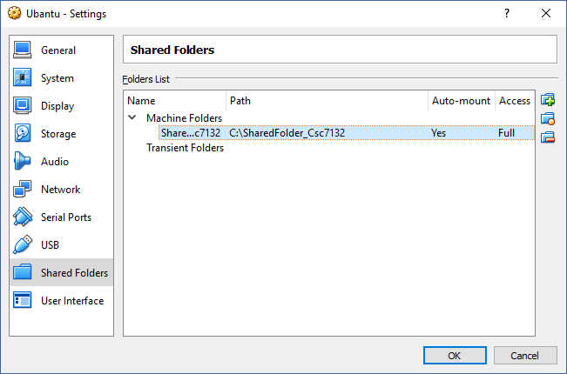

1. Click OK.
2. On Devices tab, select Insert Guest Additions CD Image...
3. The VBOXADDITIONS window pops up. Click *Run* button.
4. Enter your Ubuntu password and click *Authenticate* button.
5. TAKE A SCREENSHOT of the VirtualBox Guest Additions Installation showing the installation is success. You should see Press Return to close this window…

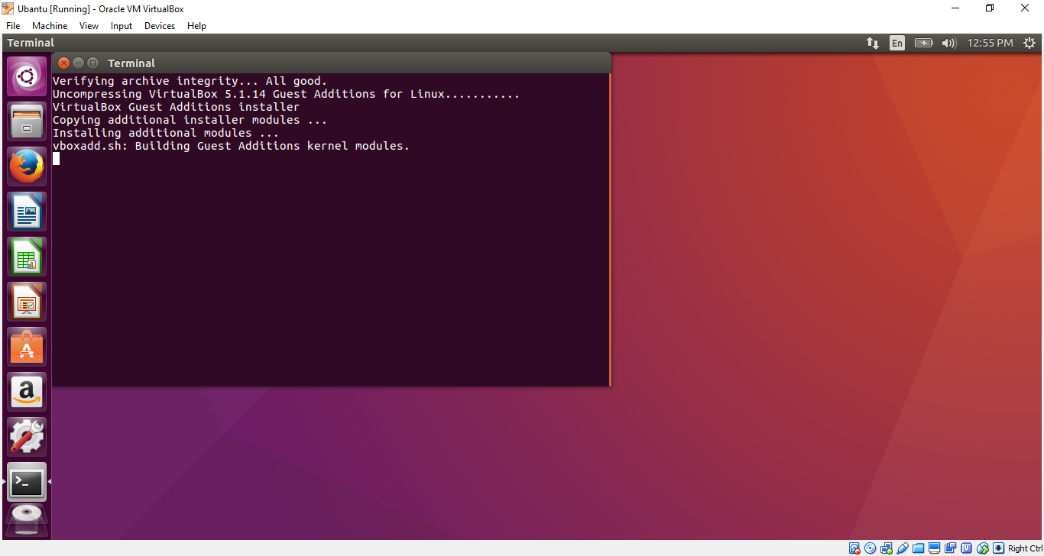

1. Press Enter to close the window.
2. Open a console/terminal and type the following statement:

*sudo adduser “*your username*” vboxsf*

1. Enter your Ubuntu password
2. Reboot Ubuntu.
3. Click Files icon, .
4. You should see sf_SharedFold*…* listed. That is your shared folder. When you click on it, its full name is listed on the top of the window.
5. TAKE A SCREENSHOT showing the SharedFolder_Csc7132 in Ubuntu.

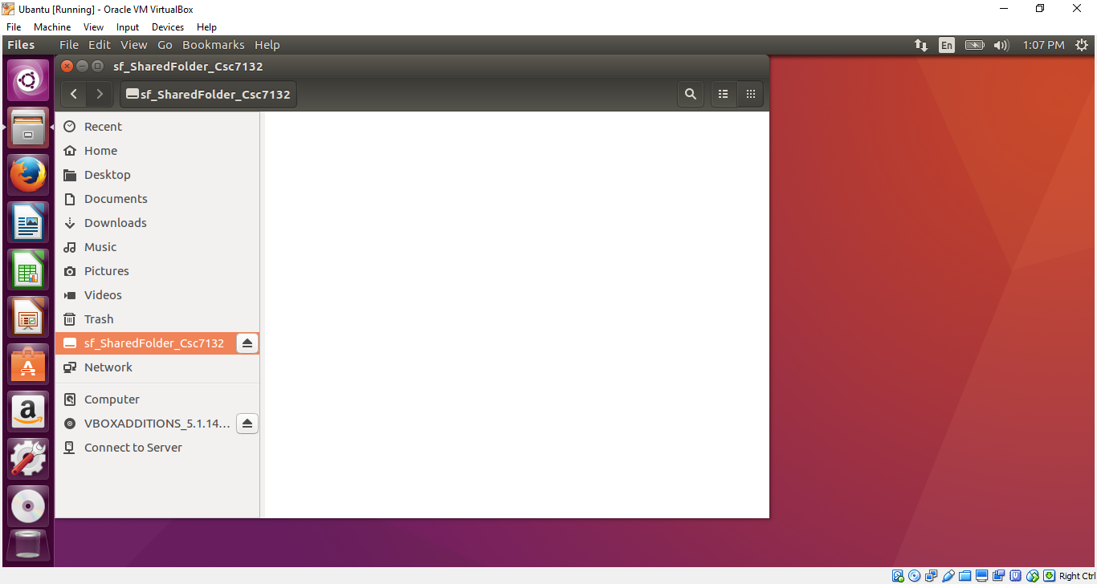

**MANIPULATE FILES**

1. Create a directory called *lab1* in Ubuntu and do all your work for this lab in this directory.
2. Write a C program called *reverseFileContent.*c to read the characters in a text file, reverse the order of the characters in the file, and write the result to an output file.

The signature of the main program:

int main (int argc, char *argv[]) {

}

Where:

* argc is the number of arguments that are passed to the program plus 1
* argv[0] is the name of the program
* argv[1] is the first argument passed to the program
* argv[2] is the second argument passed to the program

A template of the main program and the input file called *inputFile.*txt are provided to you along with this document on Blackboard. Use the following system calls to manipulate the file:

* lseek
* open
* close
* read
* write

You are required to read and manipulate ONE CHARACTER at time. Do not read the input file into memory and print it out in reverse.

To compile the program, in the same directory with the source file, type the following statement:

*gcc –o reverseFileContent reverseFileContent.c*

To execute your program type:

*./reverseFileContent inputFile.txt outputFile.txt*

1. TAKE A SCREENSHOT of your Ubuntu terminal/console and paste it here

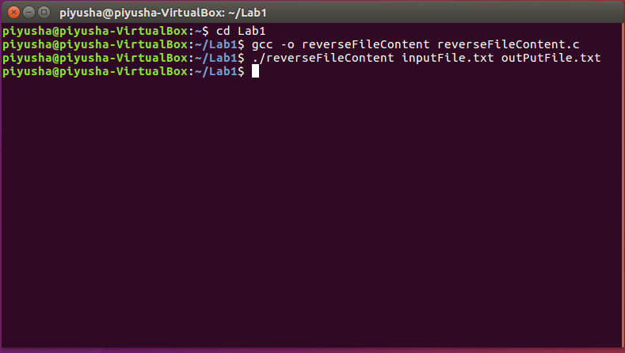

1. TAKE A SCREENSHOT of the content of the *outputFile.txt* and paste it here.

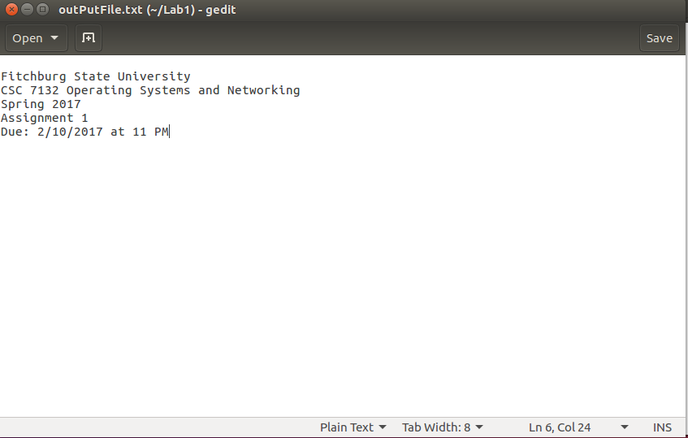

**MOVE FILES FROM UBUNTU TO WINDOWS**

1. To copy files from current directory to SharedFolder_Csc7132 directory, type:

*cp* “file-name”  */media/sf_SharedFolder_Csc7132/.*

1. Copy this document, the source code and output files to the shared folder.
2. The files should now appear in the SharedFolder_Csc7132 folder in Windows side.
3. Submit your files to Blackboard.